

*Indira College of Commerce and Science*

Android Project Report

On

*Quiz application*

M.Sc. (Computer Science) 2018-19

By

Ganesh Londhe (23), Vaibhav Jagtap (15)

M. Sc. (Comp. Sci.)-II

ICCS, Pune

**Project Certificate**

**TABLE OF CONTENTS**

**CHAPTER 1: INTRODUCTION**

1.1 Existing System and Need for System

1.2 Scope of Work

1.3 Operating Environment – Hardware and Software

**CHAPTER 2: PROPOSED SYSTEM**

2.1 Proposed System

2.2 Objectives of System

**CHAPTER 3: ANALYSIS & DESIGN**

3.1 Data Flow Diagram (DFD)

3.2 Functional Decomposition Diagram (FDD)

3.3 UML Diagrams

3.3.1 Class Diagram

3.3.2 Object Diagram

3.3.3 Use Case Diagram

3.3.4 Sequence Diagram

3.3.5 Collaboration Diagram

3.3.6 State Diagram

3.3.7 Activity Diagram

3.3.8 Component Diagram

3.3.9 Deployment Diagram

3.4 Entity Relationship Diagram (ERD)

3.5 Data Dictionary

3.6 Table Design

**CHAPTER 4: USER MANUAL**

4.1 Operations Manual / Menu Explanation

4.2 Menu Screens

4.3 Project code

**CHAPTER 5: Limitations and Enhancement**

5.1 Drawbacks and Limitations

5.2 Proposed Enhancements

5.3 Conclusions

5.4 Bibliography

**1: INTRODUCTION**

* 1. **Existing System and Need for System**

There exists an advanced system than we have created in this project. We have created a basic application to fulfill our need to learn android development during the course of three months.

* 1. **Scope of Work**

Scope of this project is limited to the students. UG, PG students and anyone who is learning to develop an android app like quiz or similar.

* 1. **Operating Environment – Hardware and Software**

Operating System: Android version 4(KitKat) and above

**2: PROPOSED SYSTEM**

**2.1 Proposed System**

This is a very basic quiz android application written in java. The inspiration for this project came from the guest lecture conducted in the Indira college with I visit this seminar.

The main design of the application follows the examples given in the lecture.

**2.2 Objectives of System**

Our main aim is to understand the logic behind the quiz application and to understand the android development.

**CHAPTER 3: ANALYSIS & DESIGN**

**3.1 Data Flow Diagram (DFD)**

Register

User_details Login

Test User

Start Complete End See Result

**3.3 UML Diagrams**

**3.3.1 Class Diagram**

LoginActivity

-email: string

-password: string

- login()

- register()

Class diagram

Subject

-php: String

-c++: String

-html: String

-java: String

+select_subject()

Register

-name: string

-email: string

- password

+register()

+login()

Questionary

- questions: string

-answers: string

+selectAnswer()

+goToNextQuestion()

+Upload_to_server()

Result

- score: Numeric

+ newText()

+ exit()

3.3.2 Object Diagram

Object diagram

LoginActivity

-email: string

-password: string

Subject

-php: String

-c++: String

-html: String

-java: String

Register

-name: string

-email: string

- password

Result

- score: Numeric

Questionary

- questions: string

-answers: string

+Upload_to_server()

**3.3.3 Use Case Diagram**

Register

Login

Select Sub

Starts Test

Ends Test

Ends Test

**Use case diagram: quiz app**

**3.3.4 Sequence Diagram**

Login

User

Register

Select Sub

Start Test

End Test

Result

Login

Register

**3.3.6 State Diagram**

Idle

Login

Register

Select sub

Start Test

End Test

Check result

**3.3.7 Activity Diagram**

Login

Register

Select Subject

Start Test

Complete Test

End Test

Check Result

Exit

**3.3.8 Component Diagram**

Register.java Login.java

Subject.java

Questionary.java

Result.java

**3.5 Data Dictionary**

Data Dictionary

Database – userManager

Table Name – "User_name”

|  |  |  |  |
| --- | --- | --- | --- |
| Column Name | Data Type | Constraints | Description |
| user_id | String | Primary Key | User id |
| user_name | String |  | User name |
| User_email | String |  | User email_id |
| Password | String |  | Contains passwords |

**4: USER MANUAL**

**4.1 Operations Manual / Menu Explanation**

User will see the Screen 1 from the following diagrams once for first five seconds. Second screen will be login screen. Where user will have to give the credentials to log in into the system. To start the test. If user is using the app for the first time. There is another link below login button “No account yet? Create one”.

Pressing on the “Create one” text user will be redirected to the register page, where user will be giving some of the primary information like user name, email id also user will be able to create his own password for the system. Once the registration is done, user will be redirected to the login page again.

Once user is logged in successfully in the system, screen 4 appears. Asking user for the subject selection. Continuing to the respective subject test. Test will get started. There is time limit to complete the test. User have choice to complete the whole test or user can quit anytime and end the test on any question.

When user choose to end the test or come to the last question of the test, user can tap on the “See result” button to check the result of the current test. After seeing result user can quit the application or may continue to another subject’s test.

**4.2 Menu Screens**

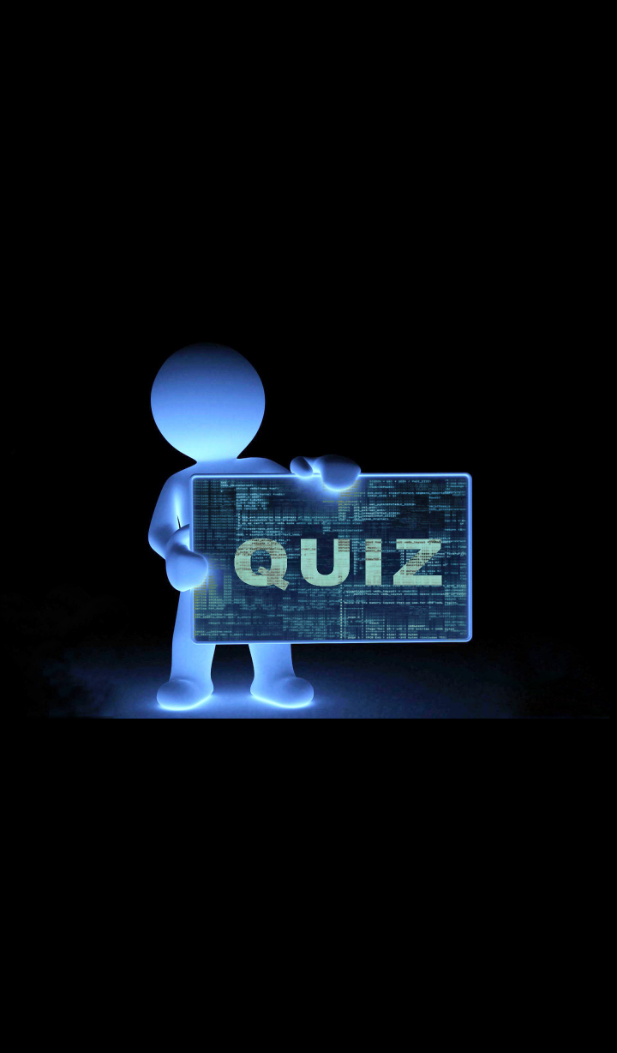

**Login Page**

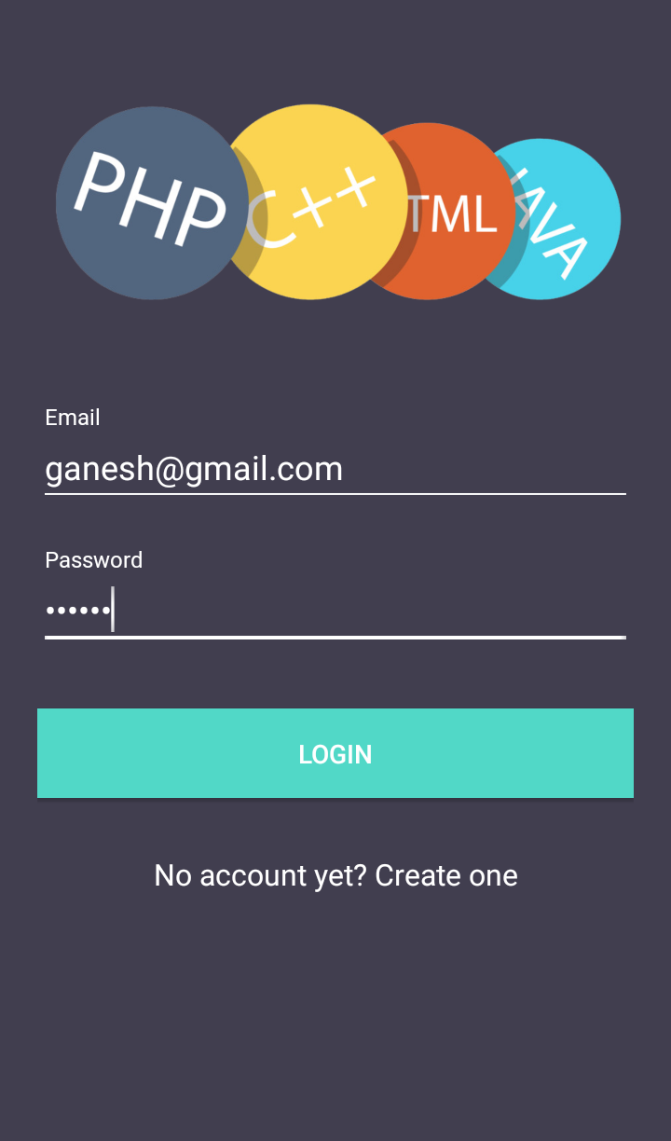

**Register Page**

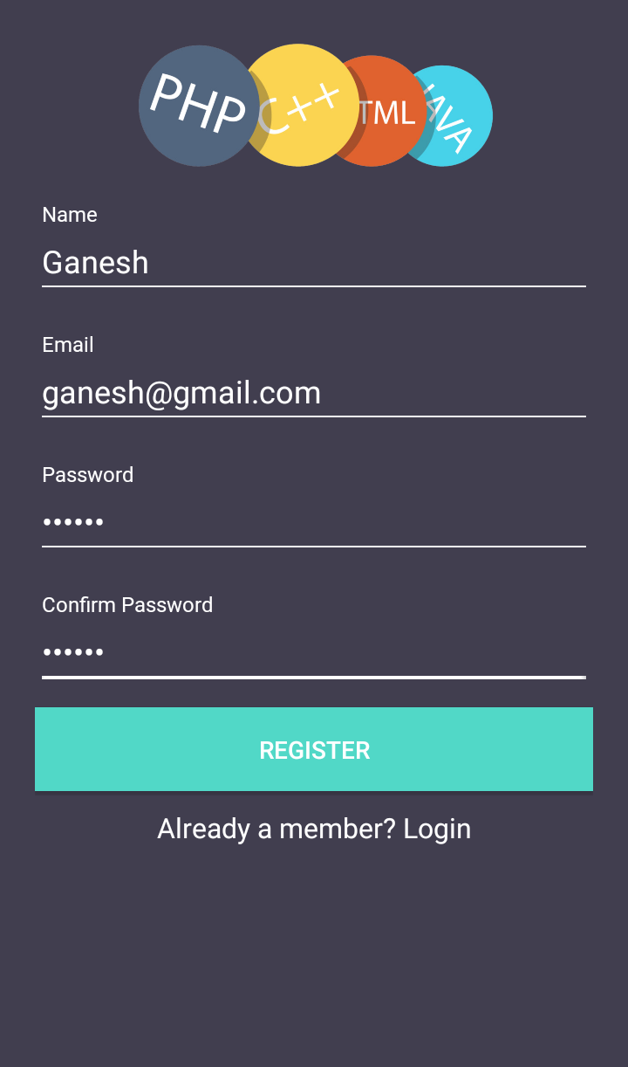

**Select Sub**

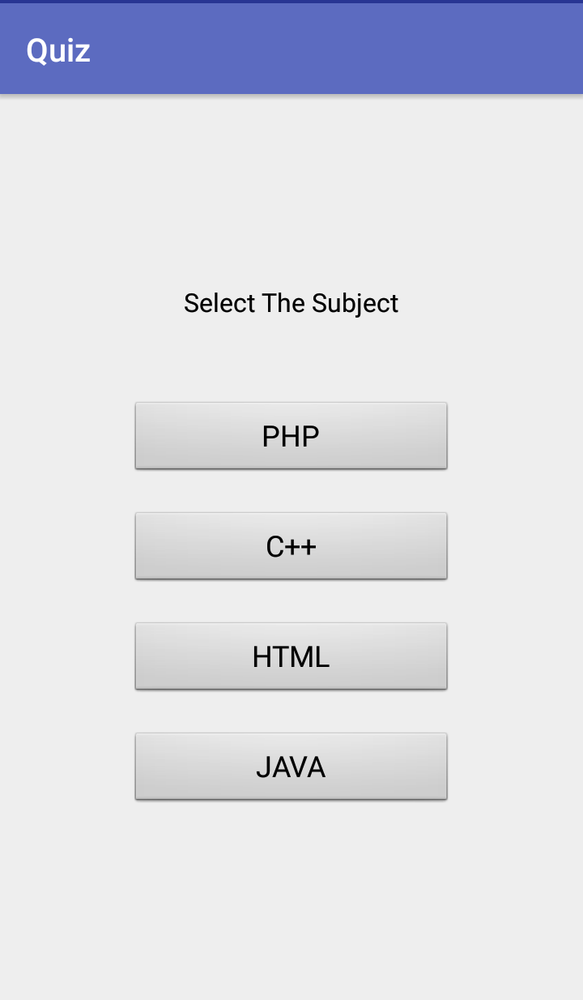

**Start Test**

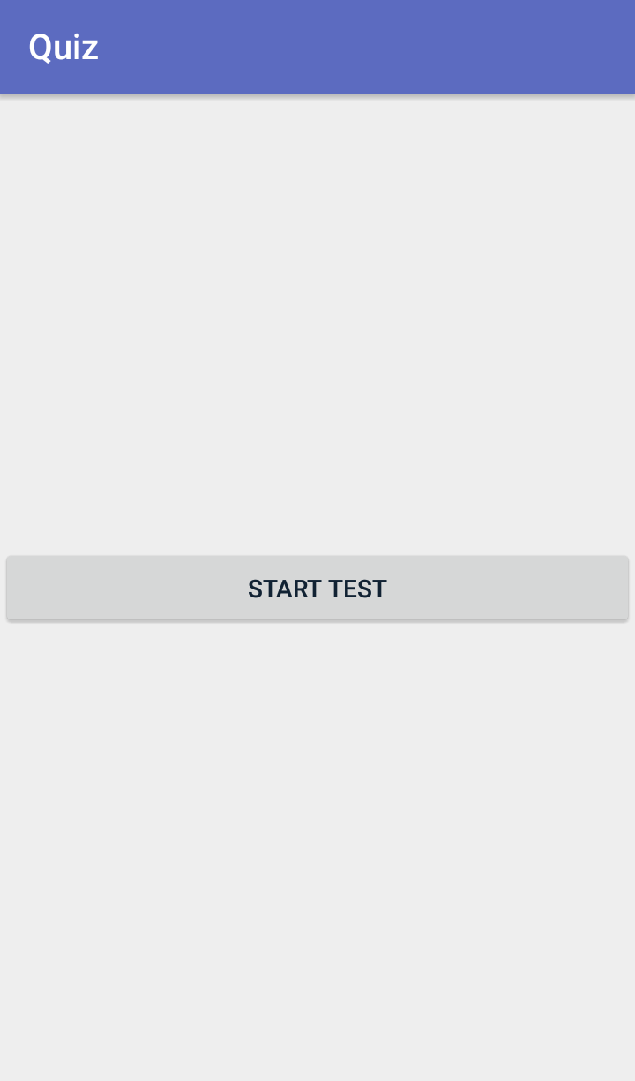

**During Test**

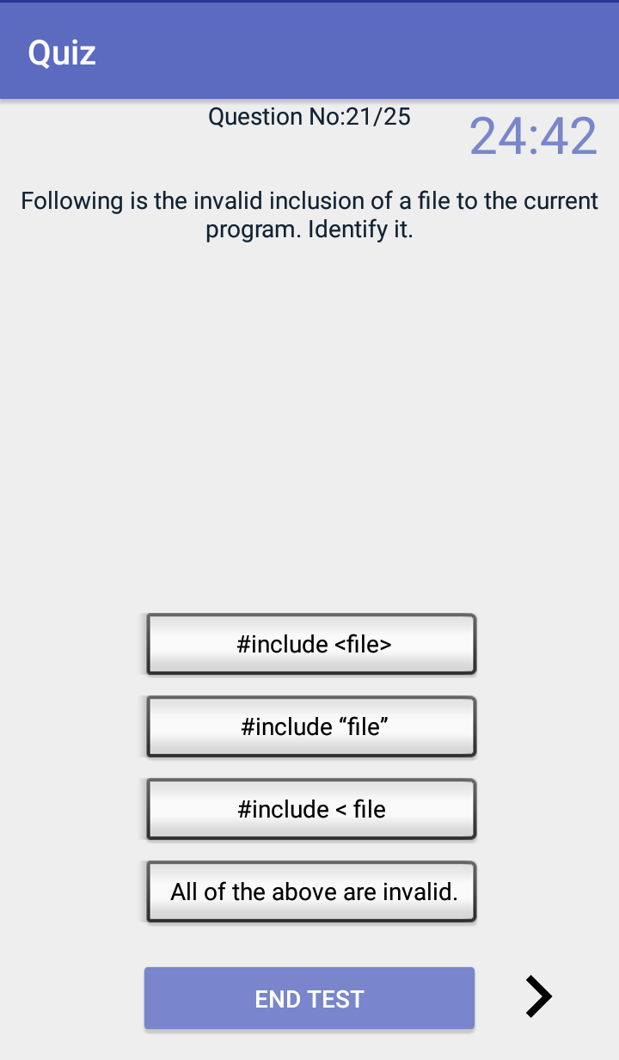

**Result Page**

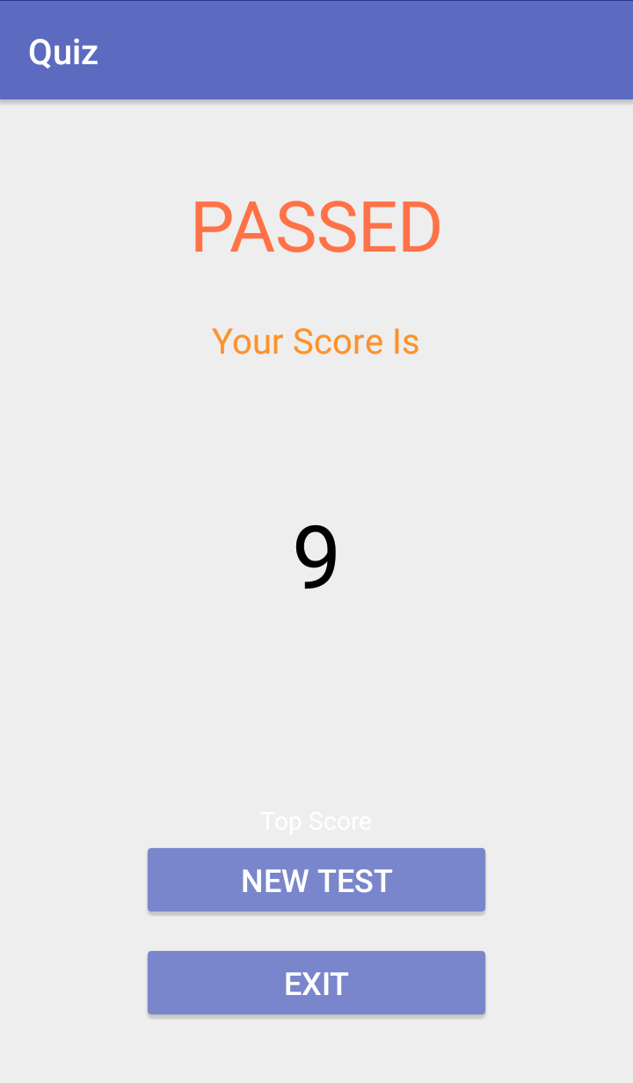

**Exit Confirmation Page**

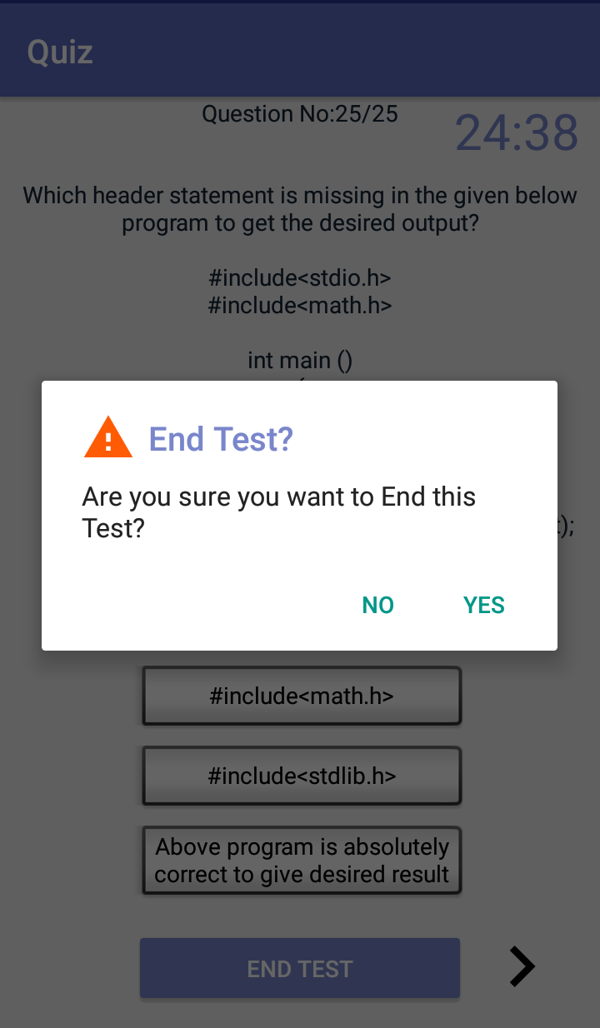

**4.3 Project code**

package com.chiku.quiz;  
  
import android.content.ContentValues;  
import android.database.Cursor;  
import android.database.sqlite.SQLiteDatabase;  
import android.support.v7.app.AppCompatActivity;  
import android.os.Bundle;  
import android.view.View;  
import android.widget.EditText;  
import android.widget.TextView;  
import android.widget.Toast;  
  
public class MainActivity extends AppCompatActivity  
{  
 EditText Name,Mail,Age,Mno,Pass;  
 YourDatabase yd;  
 SQLiteDatabase db;  
 TextView tv;  
 @Override  
 protected void onCreate(Bundle savedInstanceState)  
 {  
 super.onCreate(savedInstanceState);  
 setContentView(R.layout.*activity_main*);  
  
 Name = (EditText)findViewById(R.id.*Name*);  
 Mail = (EditText)findViewById(R.id.*mail*);  
 Mno = (EditText)findViewById(R.id.*Mno*);  
 Age = (EditText)findViewById(R.id.*Age*);  
 Pass = (EditText)findViewById(R.id.*Pass*);  
 yd = new YourDatabase(this);  
 db = yd.getWritableDatabase();  
 }  
  
 public void saveDetails(View v)  
 {  
 String name = Name.getText().toString().trim();  
 String cno = Mno.getText().toString().trim();  
 String AGE = Age.getText().toString().trim();  
 String mail = Mail.getText().toString().trim();  
 String pass = Pass.getText().toString().trim();  
  
 long contact = Long.*parseLong*(cno);  
 int age = Integer.*parseInt*(AGE);  
  
  
  
 ContentValues cv = new ContentValues();  
 cv.put(YourDatabase.*COL1*,name);  
 cv.put(YourDatabase.*COL2*,mail);  
 cv.put(YourDatabase.*COL3*,cno);  
 cv.put(YourDatabase.*COL4*,age);  
 cv.put(YourDatabase.*COL5*,pass);  
  
  
 long res = db.insert(YourDatabase.*TRABLENAME*,null,cv);  
  
 if (res != -1)  
 {  
 Toast.*makeText*(this, "Data is Inserted", Toast.*LENGTH_SHORT*).show();  
 }  
 else  
 {  
 Toast.*makeText*(this, "Invalid Data" , Toast.*LENGTH_SHORT*).show();  
 }  
 Name.setText("");  
 Mail.setText("");  
 Mno.setText("");  
 Age.setText("");  
 Pass.setText("");  
 Name.requestFocus();  
 }  
}

**5: Limitations and Enhancement**

**5.1 Drawbacks and Limitations**

* User can’t go back to the previous question
* User can’t go back to the skipped questions either
* Only valid user can make use of this software

Although the design and development are carried out in order to cover most of the functions of the system still there remains certain limitation in the system so far developed. This can be considered in further development of the project.

**5.2 Proposed Enhancements**

The project can be enhanced as per requirements of the client.

**5.3 Conclusions**

This project gave me an opportunity to understand the basic flow of an android application as per the expectation of the user and the challenges one faces during the course of developing and implementing the project successfully. We had the unique opportunity to work not just of an application but reporting a solution. An entire framework, where from a student to the top-level technician can use it to make their task easier and faster.

It gives us immense pleasure and satisfaction to do a project in a field, I have always been interested in and which allowed me to use my desire to learn new technology and use my technical skills in an excellent way to give a result which was required, which has gone beyond my own expectations.

5.4 Bibliography

During development of any project some good sources should be referred. During the development of our project we referred some useful books which good sources of knowledge are.

[www.wikipedia.com](http://www.wikipedia.com)

[www.youtube.com](http://www.youtube.com)

[www.developer.android.com](http://www.developer.android.com)